Borehole No. GM77
Location Asanyansu, Afram Plains
Latitude N 07°02.149’
Longitude W000°31.228’
Date started 28/01/2000
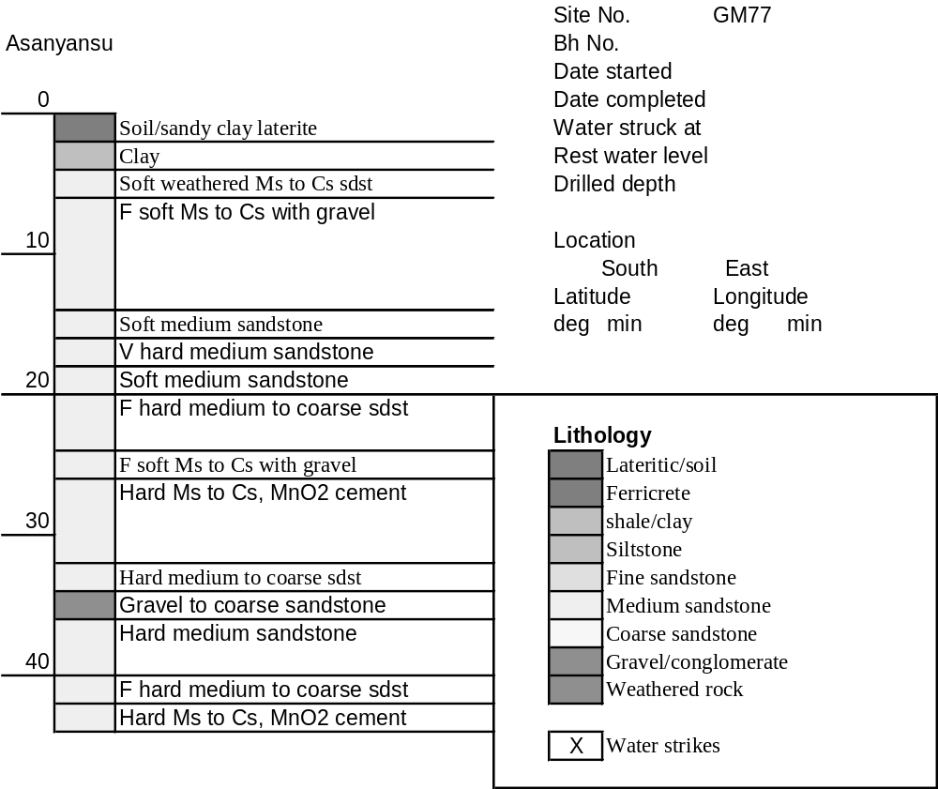Date completed 29/01/2000

Summary Lithological Log
Depth(m)
From To
0 2 Lateritic ferrecrete
2 3 Clay
3 4.1 Weathered mudstone
4.1 5.1 Sandy clay above soft weathered medium to coarse sandstone
5.1 7.1 Fairly soft medium to coarse sandstone
7.1 8.1 Gravel with vein quartz
8.1 14.2 Fairly soft medium to coarse sandstone and gravel
14.2 17.3 Soft medium sandstone
17.3 19.3 Very hard medium sandstone
19.3 20.3 Soft medium sandstone
20.3 25.4 Fairly hard medium to coarse sandstone
25.4 29.5 Fairly soft medium to coarse sandstone with some gravel
29.5 32.5 Hard medium and fine sandstone with some manganese cement in fine
sandstone
32.5 34.5 Hard medium to coarse sandstone
34.5 36.6 Gravel to coarse sandstone
36.6 39.6 Hard medium sandstone
39.6 42.7 Fairly hard to hard medium to coarse sandstone
42.7 43.7 Hard medium to coarse sandstone with manganese cement

Detailed Lithological Log
Depth(m) Lithology
From To

Lateritic ferricrete
0 1 Orange brown granular concretionary to tubular siliceous ferricrete
with red and black partings
1 2 Orange brown, red and black tubular very hard siliceous ferricrete;
above light greenish grey kaolin clay with brick red partings

Clay
2 3 Light grey kaolin clay with brown/red partings; above brown red
weathered siltstone

Weathered mudstone
3 4.1 Light brown red weathered mudstone with light greenish grey very
weathered kaolinitic bands

Sandy clay above soft weathered medium to coarse sandstone
4.1 5.1 Very weathered greenish light grey and bright yellow sandy kaolin
clay; above fairly soft medium to coarse grained weathered purple red
sandstone

Fairly soft medium to coarse sandstone
5.1 6.1 Purple brown medium to coarse grained sandstone, fairly soft with
much weathered pink matrix around rounded grains
6.1 7.1 Purple brown medium to coarse fairly soft sandstone with rounded
grains and some fine gravel

Gravel with vein quartz
7.1 8.1 Dark brown and green rounded quartzitic gravels with some vein
quartz

Fairly soft medium to coarse sandstone and gravel
8.1 9.1 Interbedded dark purple brown medium to coarse grained sandstone
and rounded to subrounded quartzitic gravels including jasper and vein
quartz
9.1 10.2 Interbedded dark purple brown medium to coarse grained sandstone
with weathered orange grains and rounded to subrounded quartzitic
gravels including jasper and vein quartz
10.2 11.2 Purple brown and pink medium to coarse sandstone, fairly soft with
interbedded fine gravel to very coarse sands with rounded clasts
11.2 12.2 Mainly medium to fine grained purple brown sandstone with pink
fragments; subordinate rounded fine gravels and very coarse sands,
cherty red and brown clasts
12.2 13.2 Brown and green rounded fine to coarse cherty gravels; interbedded
with fairly soft purple brown medium to fine grained sandstone with
pink grains
13.2 14.2 Pink/red medium to fine grained sandstones with pink grains and
interbedded rounded gravels - pink and green, cherty

Soft medium sandstone
14.2 15.2 Dark orange/red medium grained sandstone with some pink and green
gravel
15.2 16.3 Soft orange grey medium grained sandstone with many orange pink
grains
16.3 17.3 Soft orange grey medium grained sandstone with many orange pink
grains

Very hard medium sandstone
17.3 18.3 Very hard orange, pink and grey medium grained sandstone with many
pink grains
18.3 19.3 Very hard compact purple pink medium grained sandstone with green
chlorite along fracture?, pink fine grained matrix

Soft medium sandstone
19.3 20.3 Fairly soft pink/purple/brown and grey medium grained sandstone with
some pink matrix material, odd granitic gravel rounded clast

Fairly hard medium to coarse sandstone
20.3 21.3 Orange brown medium to coarse sandstone with many orange pink
fragmented grains, soft; subordinate fairly hard fine grained brown
sandstone with some orange grains and little black MnO cement
21.3 22.4 Orange brown medium to coarse sandstone with fragmented orange
grains
22.4 23.4 Fairly hard orange and grey medium to coarse grained sandstone with
fragmented orange grains
234. 24.4 Dark orange brown fairly hard medium to coarse sandstone with
orange fragmented grains
24.4 25.4 Dark orange brown medium to coarse fairly hard sandstone with odd
gravel clast; subordinate fairly hard , compact dark grey/black fine
grained sandstone with black MnO cement

Fairly soft medium to coarse sandstone with some gravel
25.4 26.4 Dark orange brown fairly soft medium to coarse grained sandstone
with odd gravel clast and fragmented grains
26.4 27.4 Dark brown/orange ferruginous medium to coarse sandstone, softish
with odd gravel clast and fragmented grains
27.4 28.5 Dark brown/orange ferruginous medium to coarse sandstone, softish
with odd gravel clast and fragmented grains
28.5 29.5 Dark brown/orange ferruginous medium to coarse sandstone, softish
with odd gravel clast and fragmented grains
Hard medium and fine sandstone with some manganese cement in fine sandstone
29.5 30.5 Dark black/brown and orange/pink medium to fine grained sandstone
with some black MnO cement in places
30.5 31.5 Dark brown/purple medium grained sandstone with NO MnO
interbedded with hard black manganiferous fine grained sandstone
31.5 32.5 Black/brown fine grained manganiferous sandstone; subordinate
orange brown medium sandstone with NO MnO

Hard medium to coarse sandstone
32.5 33.5 Hard orange black medium to coarse grained sandstone, some
manganiferous black fine grained sandstone and the odd gravel clast
33.5 34.5 Hard dark orange brown medium grained sandstone with pink grains;
subordinate hard black manganiferous siltstones with odd gravel clast

Gravel to coarse sandstone
34.5 35.6 Very weathered quartz gravel with orange coatings (water producing
layer)
35.6 36.6 Finer gravels to coarse sand, mainly hard quartz rich clasts with orange
coatings (water producing layer)

Hard medium sandstone
36.6 37.6 Orange brown medium grained sandstone with fragmented grains,
some quartz gravel
37.6 38.6 Hard orange brown medium grained sandstone
38.6 39.6 Hard orange brown medium grained sandstone

Fairly hard to hard medium to coarse sandstone
39.6 40.6 Fairly hard medium to coarse grained orange/brown sandstones with
green chlorite? on fractures (water producing layer)
40.6 41.7 Dark orange/black medium to coarse hard sandstone
41.7 42.7 Dark orange/black medium to coarse hard sandstone

Hard medium to coarse sandstone with manganese cement
42.7 43.7 Dark purple/orange/brown medium to coarse hard sandstone with
purple MnO cement and fractured grains

